**CONTENTS**

**ACKNOWLEDGEMENT 2**

**CERTIFICATE 3**

**SYNOPSIS 5**

**EXISTING SYSTEM 6**

**PROPOSED SYSTEM 4**

**USER REQUIREMENTS 8**

**HARDWARE AND SOFTWARE REQUIREMENTS 9**

**DATA FLOW DIAGRAM 10**

**DATA DICTIONARY FOR DFD 11**

**ER DIAGRAM 15**

**SCHEMA DESIGN 16**

**MODULE DESIGN 17**

**DATABASE DESIGN 18**

**INPUT AND OUTPUT SCREEN** **[21](#_Toc499237056)**

**SOURCE CODE 32**

**FUTURE ENHANCEMENTS AND CONCLUSION 33**

**BIBLOGRAPHY 34**

# 

# **SYNOPSIS**

**Title: Online Food Ordering Website For Passion Grills And Barbeque**

**Description:** This project is aimed at developing a complete online ordering system for use in a restaurant to quickly and easily manage an online menu which customers can browse and use to place orders in advance with just a few clicks. The customers will have the choice to order in advance and set the date on which they would like to have the meal ready and the payment method will be upon the day on which the order is done (manual payment). There will be a system administrator who will have the right to add and manage menu items and orders. The customer will be in a position to view the menu, place an order and track it. There will be a confirmation receipt for each and every order made by the customer which can be printed.

# **EXISTING SYSTEM**

# In the existing, the customer has to make his/her order in person in the restaurant. The customer will have to wait till a waiter comes and give them a hardcopy of the menu. The customer will also have to wait till a waiter is free to take his/her order. The customer will have to place his order without visual confirmation of what his order will look like. The customer will then have to wait for the food to be prepared which could take some time. Any advance orders is only made through the phone. The manager will have to track the bill of each table of customers based on their orders. No data or sales reports are currently being recorded.

# 

# **PROPOSED SYSTEM**

In the proposed system, customers can just visit the website to make their orders. Customers have a visual of what they order. The Admin will have his own account in which he/she could add, edit or delete menu items. Whenever a new customer makes a new order, or edits or cancels an order the Admin will receive a notification. The Admin/manager can view the orders that are made. Customers can view only their orders. Customers can make advance orders and track their order’s status. Customers can cancel their orders and the system will decide whether the order can still be cancelled. The Admin/manager can print receipts for the orders. The Admin/manager can also view a report for the recent sales of the food product.

**Features/Application:**

1. **Admin Area:** The Admin will have his own account which he could log in. Here he could add, edit and delete menu items. He could also view orders here and add or remove homepage content.
2. **Cancelling Orders:** Customers can cancel only advance orders. Orders cannot be cancelled on the day it is due**.**
3. **Cart:** Each customer will have his/her own cart in which he could add or remove any menu items from the menu.
4. **OTP confirmation:** An OTP number will be sent to the customer to confirm his/her order.
5. **Track Order:** A customer can track his/her order by giving entering his phone number and order ID to check the status of his order.
6. **Feedback:** A customer can also send his feedback to the restaurant.
7. **Report:** A Sales report will be displayed in the form of a graph.

# **USER REQUIREMENTS**

* **Software Requirements for User:**
  + **Operating system: Windows 7/Windows 8 /Windows 10**
  + **Browser: Google Chrome or any web browser**
  + **Internet Connection**
* **Hardware Requirements for User:**
  + **Processor: Intel dual core or above**
  + **Processor Speed: 1.0 GHZ or above**
  + **RAM: 1 GB RAM or above**
  + **Hard Disk: 1 GB hard disk or above**
  + **Printer for printing reports**
  + **Uninterrupted power supply to ensure a constant access of data.**

# **HARDWARE AND SOFTWARE REQUIREMENTS**

* **Software Requirements for Developer:**
  + Operating system: Windows 7/Windows 8/Windows 10
  + Technology : PHP/HTML/CSS/Javascript
  + Database : MySQL
  + Tool : Dreamweaver
  + Server: wamp
* **Hardware Requirements for Developer:**
  + **Processor:** Intel dual core or above
  + **Processor Speed:** 1.0 GHZ or above
  + **RAM:** 1 GB RAM or above
  + **Hard Disk:** 20 GB hard disk or above
  + Uninterrupted power supply to ensure a constant access of data.

# **DATA FLOW DIAGRAM**

# **DATA DICTIONARY FOR DFD**

# **ER DIAGRAM**

# **SCHEMA DESIGN**

# **MODULE DESIGN**

**ONLINE FOOD ORDERING**

**Master Entry:**

* **Adds, Edit or Delete a menu item**

**Transaction:**

* **Order: An order consisting of different menu items and any quantity of the items can be placed and a bill based on the order a bill is generated.**

**Report:**

* **Generates a report on sales on a monthly basis or yearly in the form of a graph**

# **DATABASE DESIGN**

# 

# **INPUT AND OUTPUT SCREEN**

HOMEPAGE

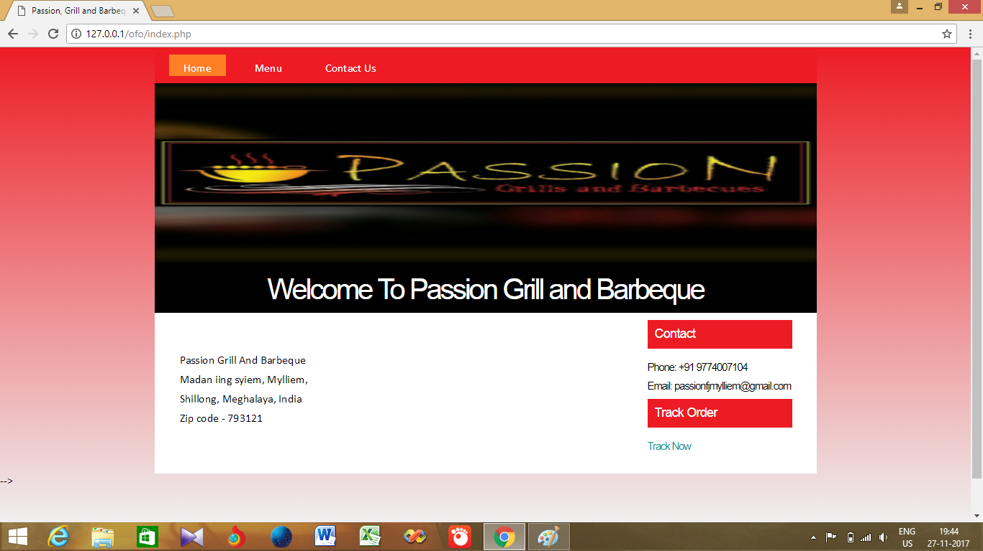

MENU PAGE

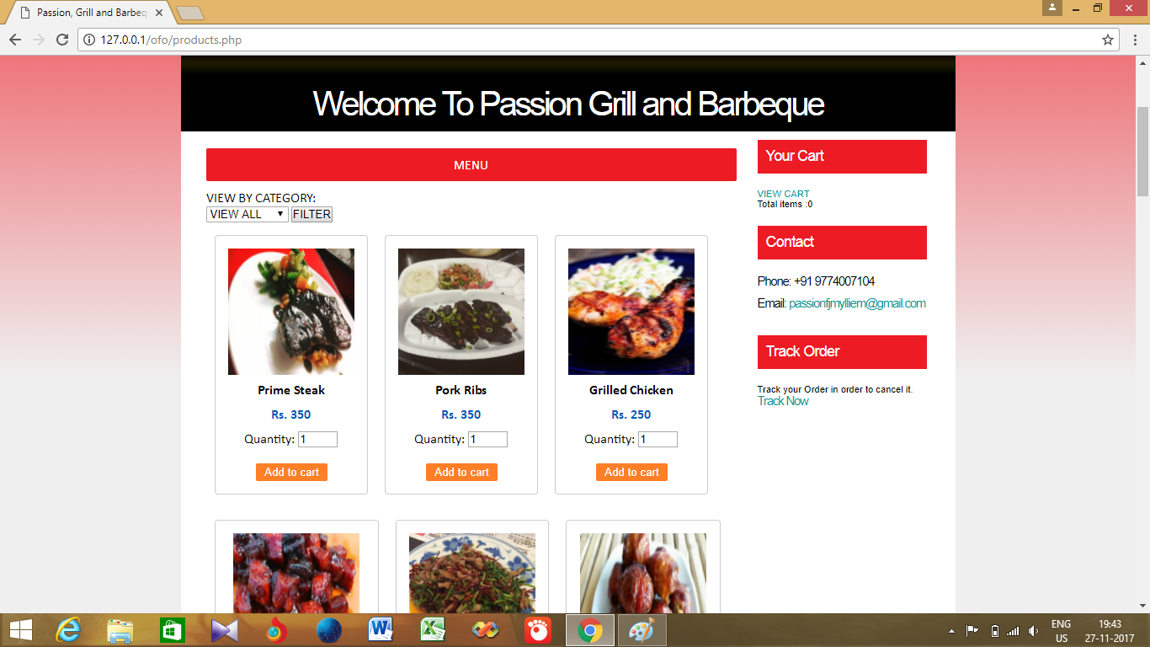

CONTACT PAGE

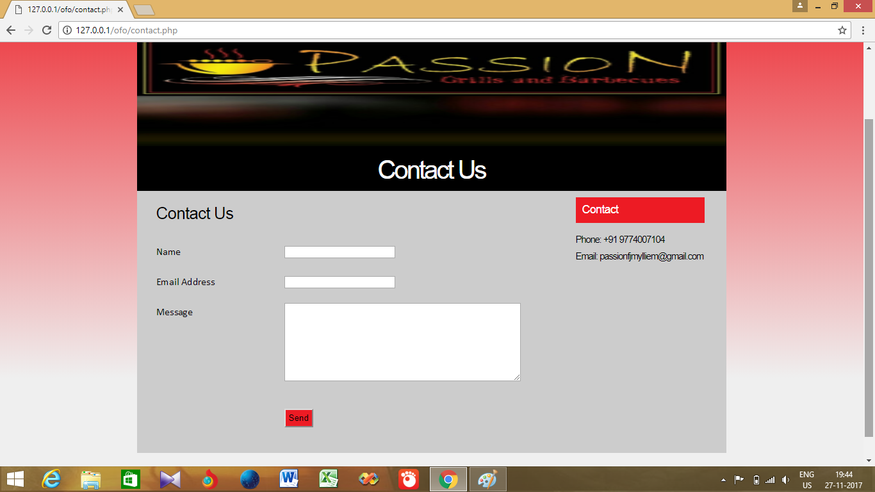

ADMIN LOGIN

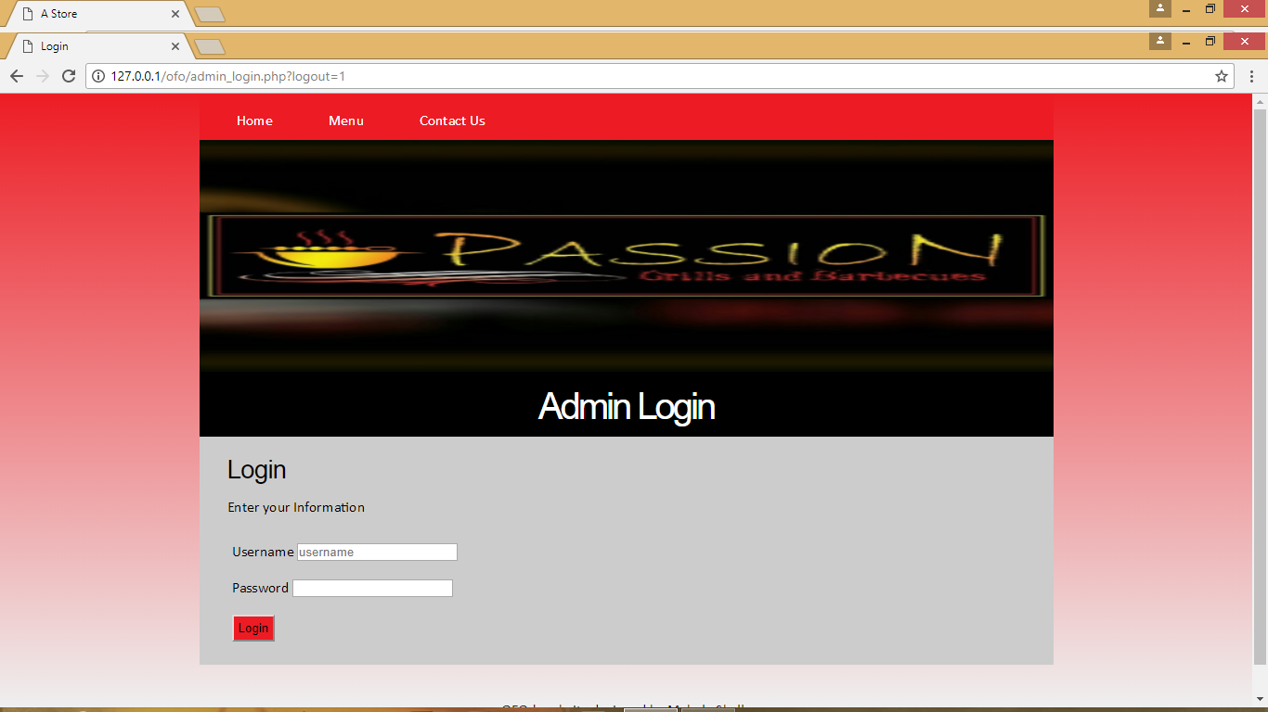

ADMIN AREA

# **C:\Users\Mebala\Desktop\Images\AdminArea.png**

ADD MENU ITEM

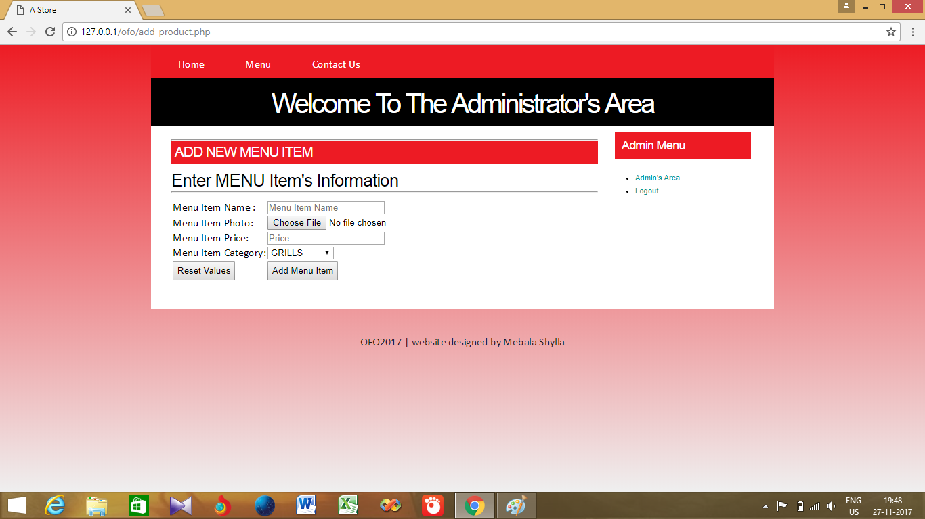

VIEW MENU ITEM

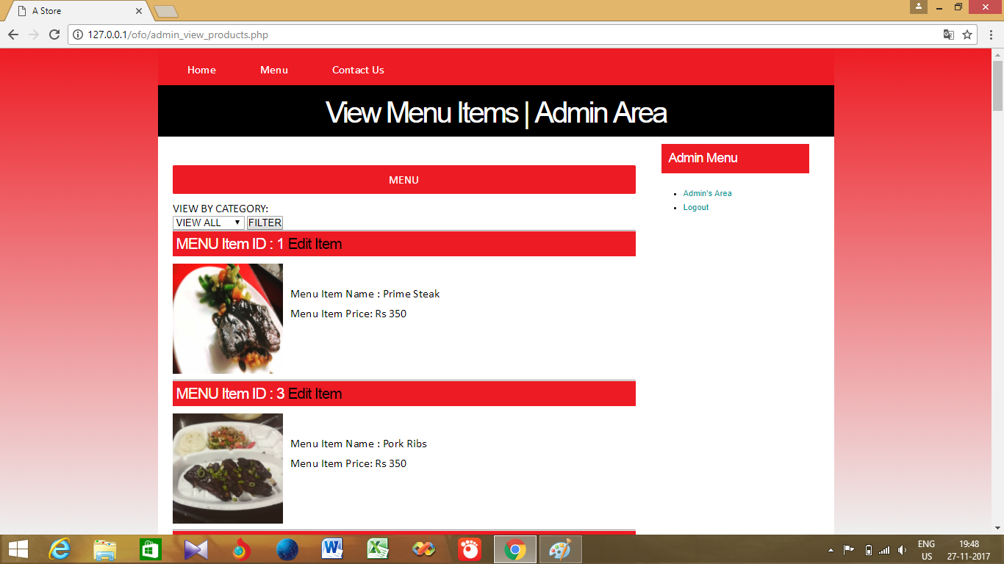

EDIT MENU ITEM

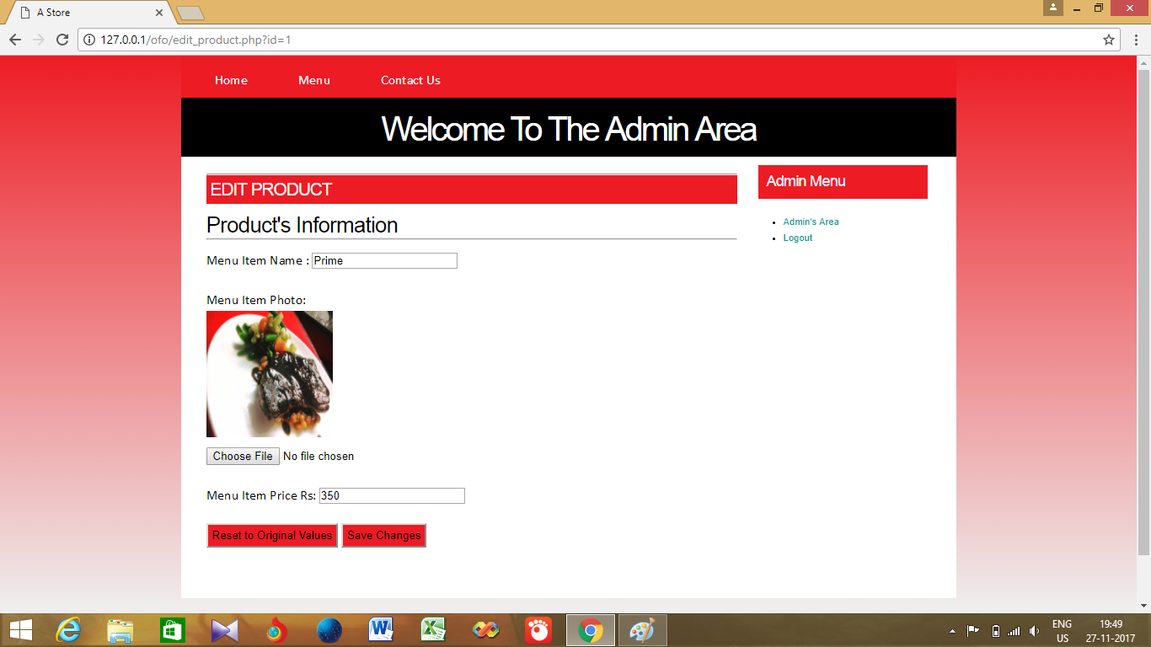

REMOVE MENU ITEM

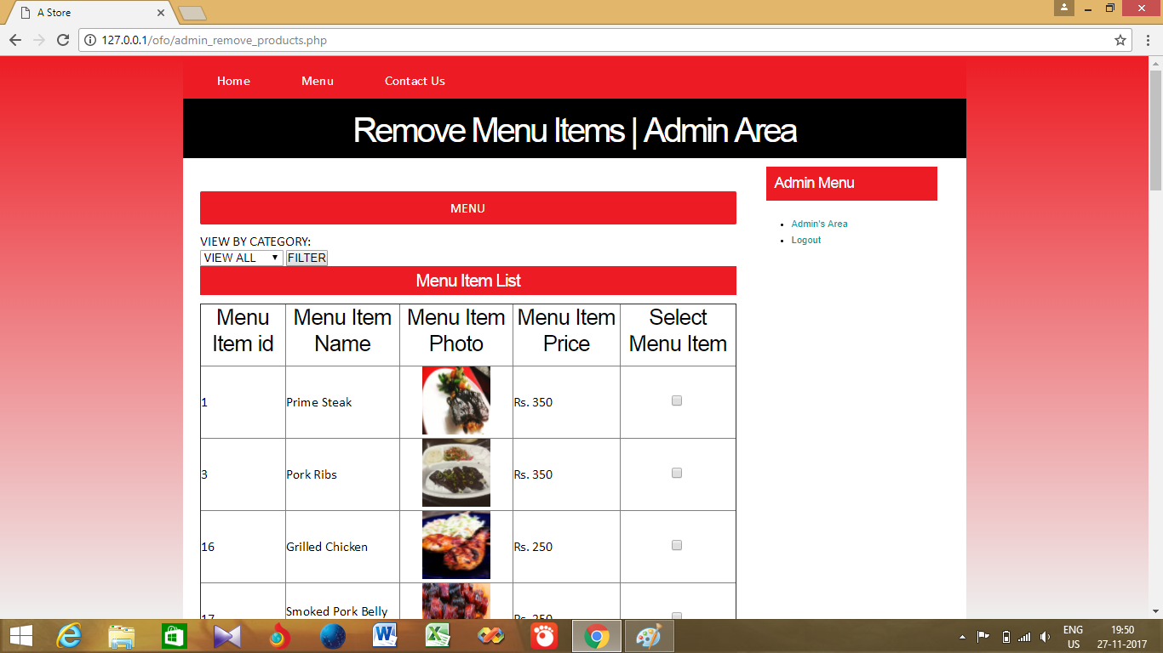

VIEW ORDERS

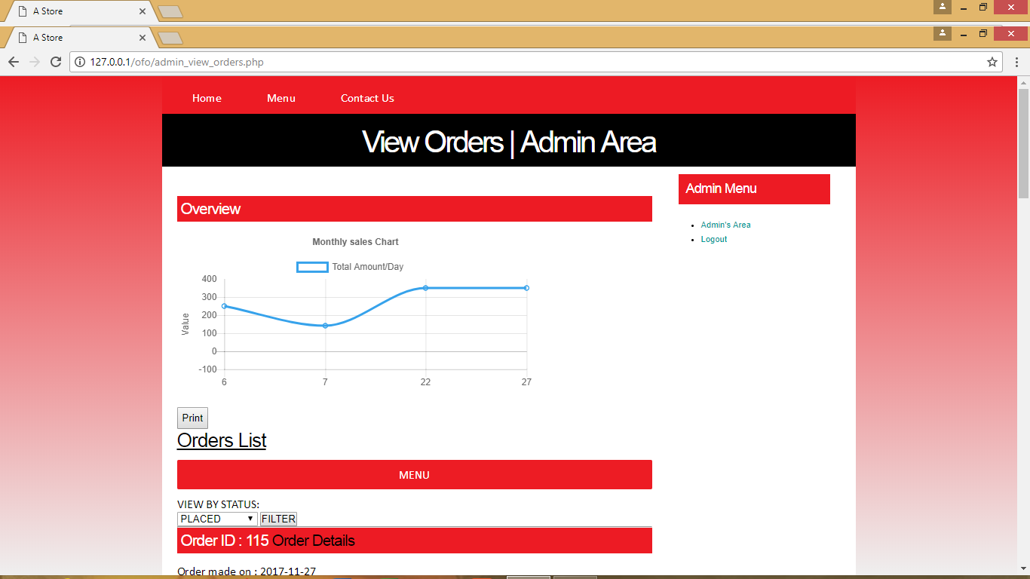

VIEW ORDERS

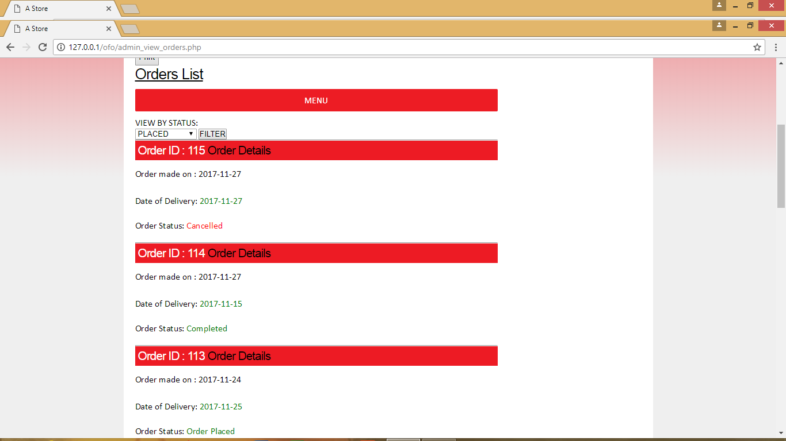

EDIT ORDERS

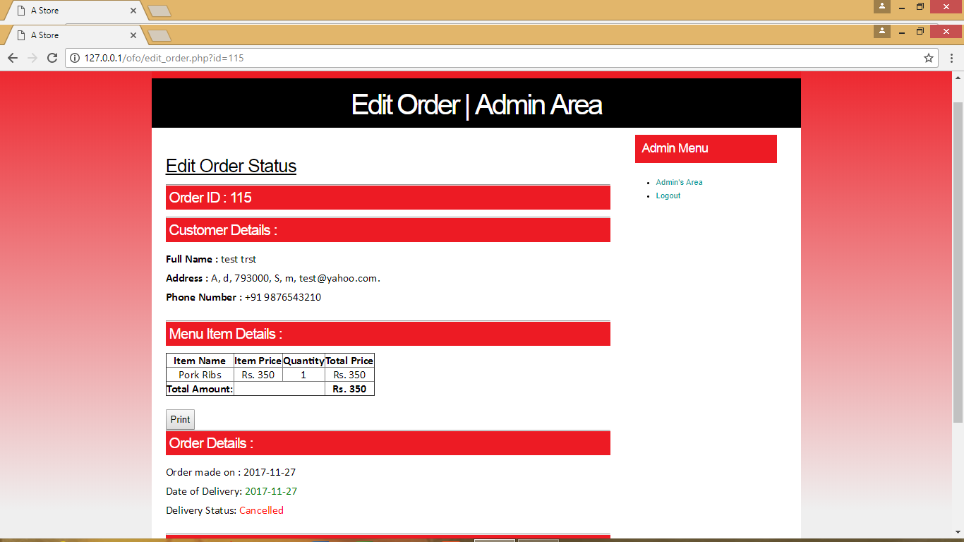

REMOVE ORDERS

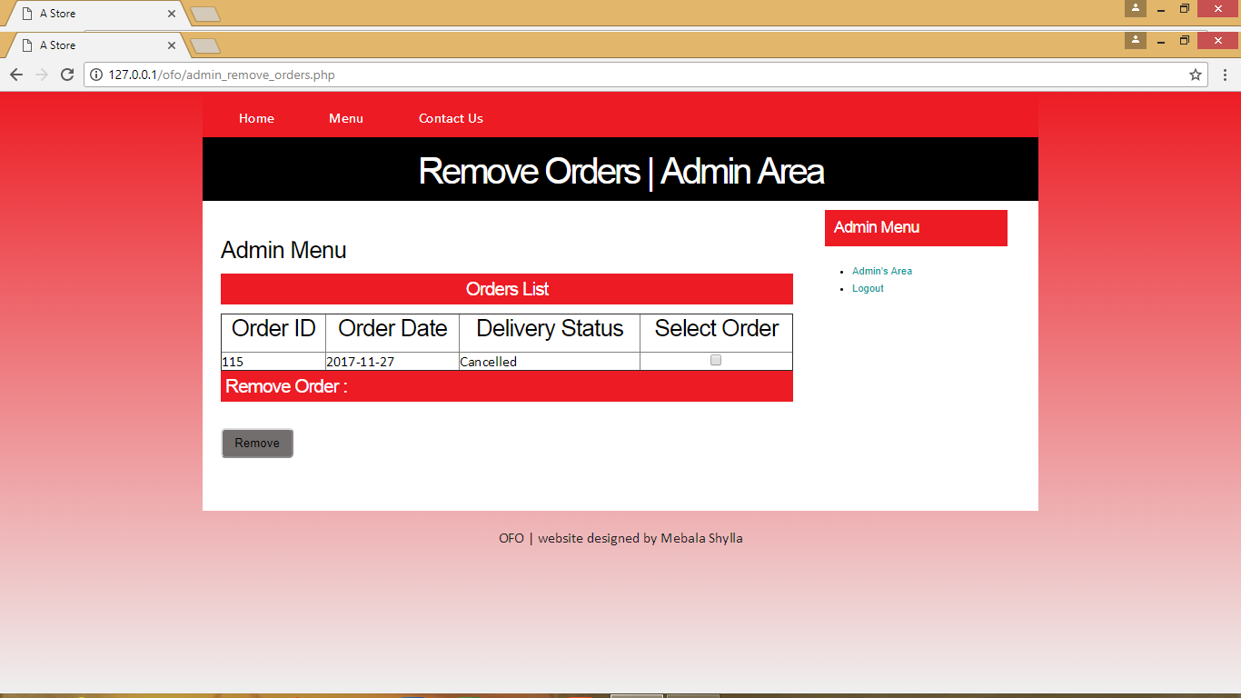

VIEW HOMEPAGE CONTENT

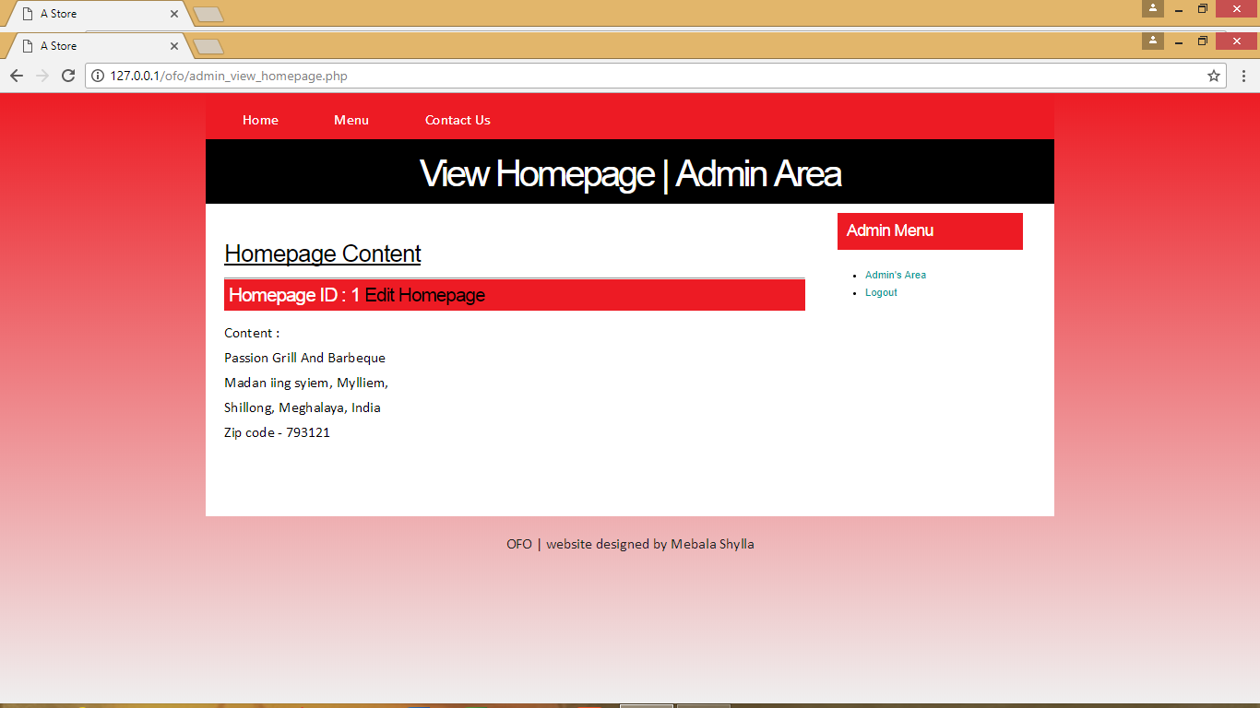

EDIT HOMEPAGE CONTENT

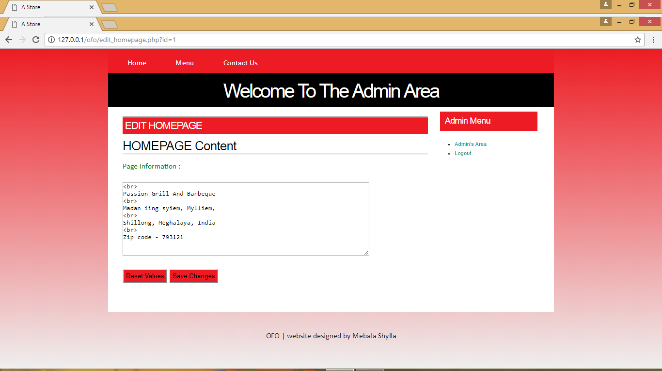

REMOVE HOMEPAGE CONTENT



CART

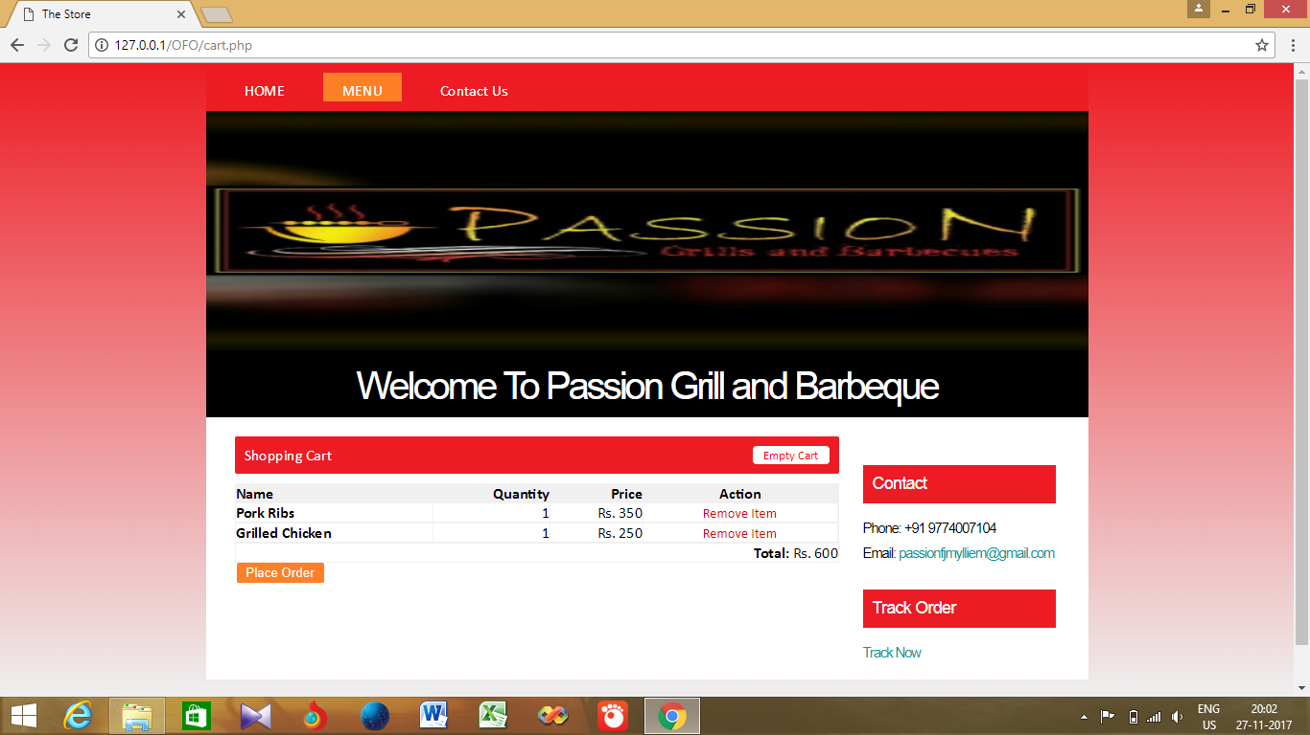

MAKE ORDER

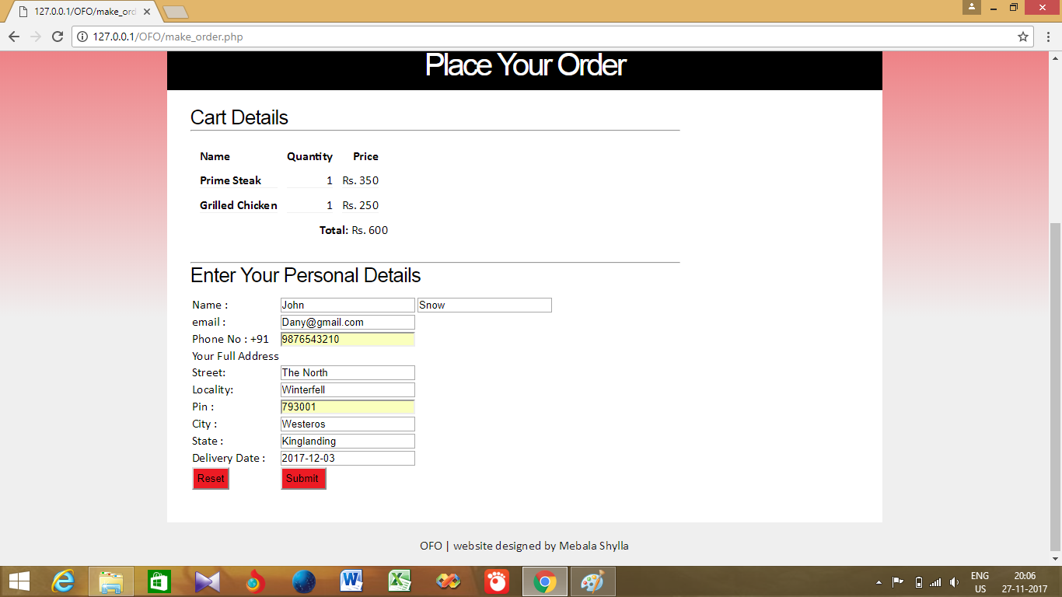

CONFIRM ORDER

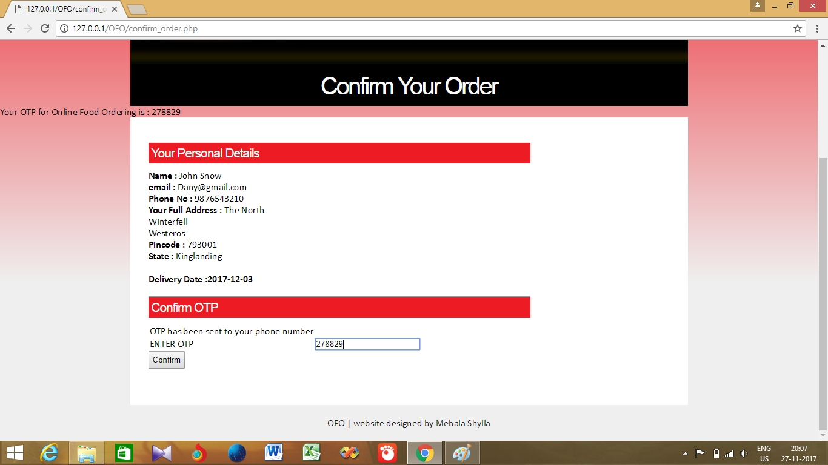

ORDER CONFIRMED

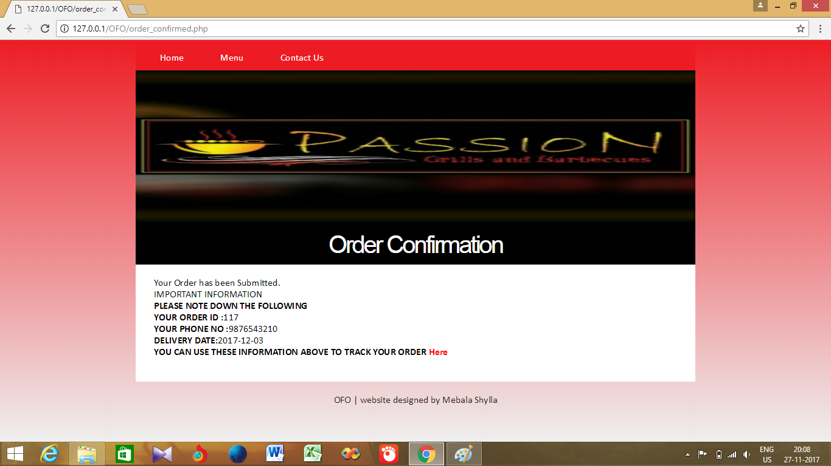

TRACK ORDER

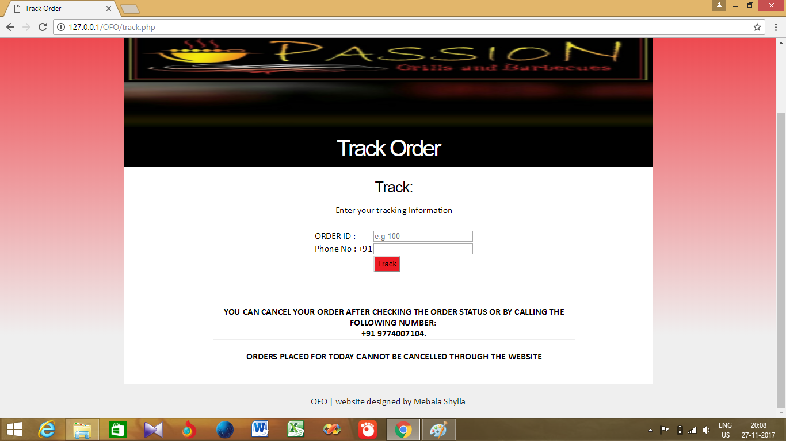

TRACK ORDER

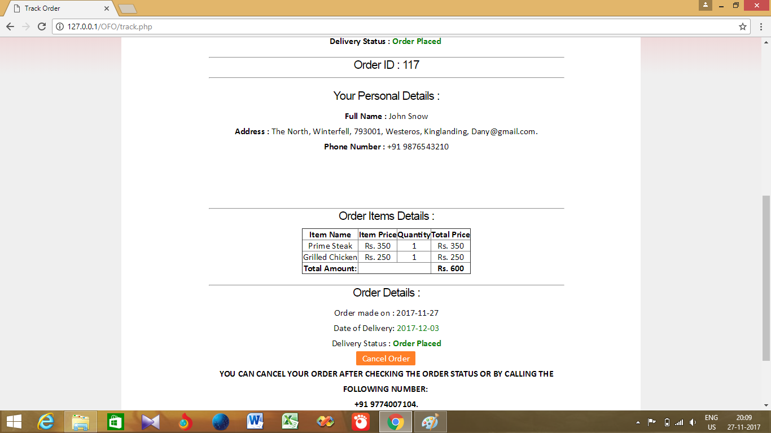

# **SOURCE CODE**

# **CD ATTACHMENT**

# **FUTURE ENHANCEMENTS**

Future enhancement, to propose to the client to implement online payment. To allow the daily tracking of menu stock so that menu items that have run out cannot be ordered anymore.

To not allow Admin to remove those menu items which are present in any orders.

# **CONCLUSION**

This website is aimed for making food ordering more efficient for both the restaurant and for the customer. As compared to the existing system the customer can order his food online and in advance without the inconvenience of travelling so far to the restaurant and having to wait even longer for his food to be prepared. On the restaurant’s side it can get advance orders and start preparing the meals on the specified date. The customer would just come to the restaurant show his order no. and wait(a lot lesser) for his food to be brought to his/her table.

# **BIBLOGRAPHY**

* PHP and MySQL by O’Reily
* <http://w3schools.com/>
* <http://phppoint.com/>
* <http://php.net/>
* <http://code.jquery.com/>